ExNum 6 - Implement rule based, pattern-based and machine learning algorithms for information extraction on clinical text and generate structured datasets.
The 6th ex. which provides three different methods to extract structured data from clinical text:
- Rule-Based Approach: Uses regular expressions to directly extract data based on predefined patterns. It is simple and fast but may not handle variations in text well.
- Pattern-Based Approach: Uses specific patterns or keywords to extract data, similar to rule-based but more flexible in terms of matching text.
- Machine Learning Approach: Uses the Naive Bayes classifier to predict diagnoses based on tokenized text features. This approach can learn from data and improve with more examples but requires more computational resources.
Each approach has its strengths and limitations, making them suitable for different types of text data extraction tasks in healthcare.
from sklearn.feature_extraction.text import CountVectorizer
from sklearn.naive_bayes import MultinomialNB

# Sample clinical data
clinical_data = [
"Patient ID: 001, Age: 45, Diagnosis: Diabetes",
"Patient ID: 002, Age: 60, Diagnosis: Hypertension",
"Patient ID: 003, Age: 29, Diagnosis: Diabetes",
“Patient ID: 004, Age: 40, Diagnosis: BloodPressure”,
“Patient ID: 005, Age: 52, Diagnosis: Depression”
]

# Rule-based approach using regex
def rule_based_extraction(data):
return [re.findall(r'Patient ID: (\d+), Age: (\d+), Diagnosis: (\w+)', record) for record in data]

# Pattern-based approach using text patterns
def pattern_based_extraction(data):
patterns = ["Patient ID", "Age", "Diagnosis"]
extracted_data = []
for record in data:
record_data = []
for pattern in patterns:
match = re.search(f'{pattern}: (\w+)', record)
record_data.append(match.group(1) if match else None)
extracted_data.append(tuple(record_data))
return extracted_data

# Machine learning approach using Naive Bayes
def machine_learning_extraction(data):
vectorizer = CountVectorizer()
X = vectorizer.fit_transform(data)
y = [record.split(", ")[2].split(": ")[1] for record in data]
clf = MultinomialNB().fit(X, y)
predictions = clf.predict(X)
return list(zip([record.split(", ")[0].split(": ")[1] for record in data], y, predictions))

# Extracting structured data using different approaches
rule_based_result = rule_based_extraction(clinical_data)
pattern_based_result = pattern_based_extraction(clinical_data)
machine_learning_result = machine_learning_extraction(clinical_data)

# Display results
print("Rule-based Extraction:", rule_based_result)
print("Pattern-based Extraction:", pattern_based_result)
print("Machine Learning Extraction:", machine_learning_result)

The provided Python code demonstrates three different approaches to extract structured data from clinical text: rule-based, pattern-based, and machine learning. Each method is implemented to extract specific information (like patient ID, age, and diagnosis) from the given clinical data.
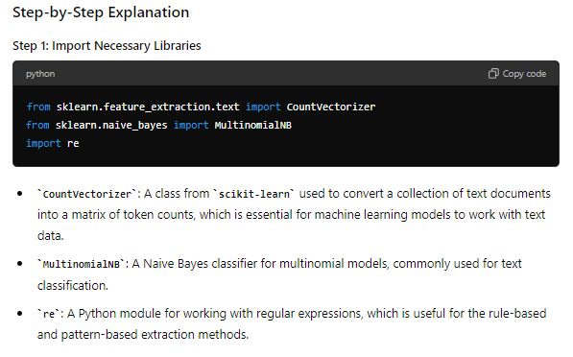
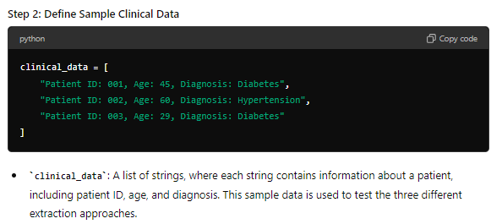
Step 3: Rule-Based Extraction Using Regex
def rule_based_extraction(data):
return [re.findall(r'Patient ID: (\d+), Age: (\d+), Diagnosis: (\w+)', record) for record in data]
rule_based_extraction: A function that extracts structured data from the clinical text using regular expressions.
- re.findall: This function searches for patterns in the text. The regular expression r'Patient ID: (\d+), Age: (\d+), Diagnosis: (\w+)' is used to find and extract:
  - (\d+): Matches one or more digits for the patient ID and age.
  - (\w+): Matches one or more word characters for the diagnosis.
- Output: Returns a list of tuples where each tuple contains extracted information for each patient.
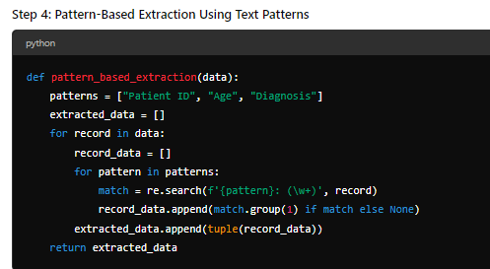
pattern_based_extraction: A function that extracts data based on simple text patterns.
- patterns: A list of key phrases to look for in the clinical data ("Patient ID", "Age", "Diagnosis").
- extracted_data: An empty list initialized to store the extracted data.
- Nested Loop: Iterates through each record and each pattern to extract data.
  - re.search: Searches for each pattern in the record using a regular expression that matches the text following the pattern (e.g., Patient ID: 001).
  - match.group(1): Extracts the matched text if found, otherwise returns None.
- Output: Returns a list of tuples containing the extracted data for each patient
Step 5: Machine Learning Approach Using Naive Bayes
def machine_learning_extraction(data):
vectorizer = CountVectorizer()
X = vectorizer.fit_transform(data)
y = [record.split(", ")[2].split(": ")[1] for record in data]
clf = MultinomialNB().fit(X, y)
predictions = clf.predict(X)
return list(zip([record.split(", ")[0].split(": ")[1] for record in data], y, predictions))

machine_learning_extraction: A function that uses a machine learning model (Naive Bayes) to classify the text data based on extracted features.
- CountVectorizer(): Converts the clinical data into a matrix of token counts.
  - X: The result of transforming data using CountVectorizer, creating a sparse matrix where rows correspond to records and columns correspond to the presence of words.
- y: A list comprehension that extracts the diagnosis labels (Diabetes, Hypertension) from each record in data.
  - [record.split(", ")[2].split(": ")[1] for record in data]: This extracts the diagnosis by splitting the record and selecting the diagnosis part.
- MultinomialNB(): A Naive Bayes classifier trained on the token counts (X) and diagnosis labels (y).
  - clf.fit(X, y): Trains the classifier on the input data.
- clf.predict(X): Predicts the labels for the input data using the trained classifier.
- list(zip(...)): Combines the extracted patient IDs, actual diagnoses, and predicted diagnoses into a list of tuples.
- Output: Returns a list of tuples containing patient ID, actual diagnosis, and predicted diagnosis.
Step 6: Extracting Structured Data Using Different Approaches
rule_based_result = rule_based_extraction(clinical_data)
pattern_based_result = pattern_based_extraction(clinical_data)
machine_learning_result = machine_learning_extraction(clinical_data)
• rule_based_result: Extracts structured data using the rule-based approach.
• pattern_based_result: Extracts structured data using the pattern-based approach.
• machine_learning_result: Extracts structured data using the machine learning approach
Step 7: Display Results
print("Rule-based Extraction:", rule_based_result)
print("Pattern-based Extraction:", pattern_based_result)
print("Machine Learning Extraction:", machine_learning_result)
print: Displays the results of each extraction method for comparison. This output helps in understanding how each method performs and the differences in their results.
output
Rule-based Extraction: [[('001', '45', 'Diabetes')], [('002', '60', 'Hypertension')], [('003', '29', 'Diabetes')]]
Pattern-based Extraction: [('001', '45', 'Diabetes'), ('002', '60', 'Hypertension'), ('003', '29', 'Diabetes')]
Machine Learning Extraction: [('001', 'Diabetes', 'Diabetes'), ('002', 'Hypertension', 'Hypertension'), ('003', 'Diabetes', 'Diabetes')]

